**RESERVOIR CONTINUUM SAMPLING FIELD and TRACKING SHEET**

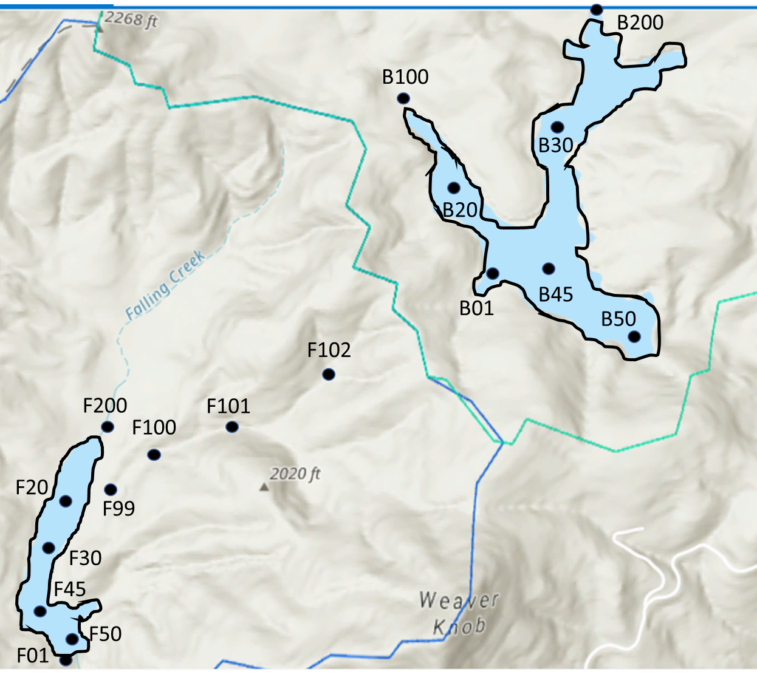**Reservoir: ______________________________________**

**Date: _____________________________________________**

**Weather: ________________________________________**

**Crew: ____________________________________________**

ALL SAMPLES AND MEASUREMENTS COLLECTED @ SURFACE (~0.1m)

|  |  |
| --- | --- |
| **Samples collected** | **List sites collected** |
| Chlorophyll-a |  |
| Total nutrients |  |
| Soluble nutrients |  |
| EEMs |  |
| BDOC |  |
|  |  |
|  |  |

|  |  |  |  |  |  |
| --- | --- | --- | --- | --- | --- |
| **Physical Measurements** | | | | | |
| Temp Sensor ID: ______________DO Sensor ID: ________________Cond Sensor ID: ___________________ | | | | | |
| **Site** | **Time** | **Temp (C)** | **DO (mgL)** | **DO %Sat** | **Sp Cond** |
|  |  |  |  |  |  |
|  |  |  |  |  |  |
|  |  |  |  |  |  |
|  |  |  |  |  |  |
|  |  |  |  |  |  |
|  |  |  |  |  |  |
|  |  |  |  |  |  |
|  |  |  |  |  |  |
|  |  |  |  |  |  |
|  |  |  |  |  |  |
|  |  |  |  |  |  |
|  |  |  |  |  |  |

NOTES:

**DISCHARGE FIELD DATA SHEET**

|  |  |  |  |  |  |
| --- | --- | --- | --- | --- | --- |
| **Discharge** | | | | | |
| Flowmeter Sensor ID | Date | Site | Width Interval (m) | Depth (cm) | Velocity (**ft/s** or **m/s**) |
|  |  |  |  |  |  |
|  |  |  |  |  |  |
|  |  |  |  |  |  |
|  |  |  |  |  |  |
|  |  |  |  |  |  |
|  |  |  |  |  |  |
|  |  |  |  |  |  |
|  |  |  |  |  |  |
|  |  |  |  |  |  |
|  |  |  |  |  |  |
|  |  |  |  |  |  |
|  |  |  |  |  |  |
|  |  |  |  |  |  |
|  |  |  |  |  |  |
|  |  |  |  |  |  |
|  |  |  |  |  |  |
|  |  |  |  |  |  |
|  |  |  |  |  |  |
|  |  |  |  |  |  |
|  |  |  |  |  |  |
|  |  |  |  |  |  |
|  |  |  |  |  |  |
|  |  |  |  |  |  |
|  |  |  |  |  |  |
|  |  |  |  |  |  |
|  |  |  |  |  |  |
|  |  |  |  |  |  |
|  |  |  |  |  |  |
|  |  |  |  |  |  |
|  |  |  |  |  |  |
|  |  |  |  |  |  |
|  |  |  |  |  |  |
|  |  |  |  |  |  |
|  |  |  |  |  |  |
|  |  |  |  |  |  |
|  |  |  |  |  |  |
|  |  |  |  |  |  |

**Salt Slug Discharge Datasheet**

***Make sure to turn conductivity meter to **Specific Conductance** (hit mode once)***

|  |  |  |  |  |  |
| --- | --- | --- | --- | --- | --- |
| **Date** | **Site** | **Width (m)** | **Depth (cm)** | **Background Sp Cond (uS)** | **Salt slug added (g)** |
|  |  |  |  |  |  |

|  |  |
| --- | --- |
| **Calibration curve** | |
| **Water added (L)** |  |
| **NaCl added (g)** | **Specific Conductance (uS)** |
| 0 |  |
| 5 |  |
| 15 |  |
| 40 |  |
| 90 |  |
| 190 |  |

|  |  |  |  |  |  |
| --- | --- | --- | --- | --- | --- |
| **Time** | **Sp Cond (uS)** | **Time** | **Sp Cond (uS)** | **Time** | **Sp Cond (uS)** |
|  |  |  |  |  |  |
|  |  |  |  |  |  |
|  |  |  |  |  |  |
|  |  |  |  |  |  |
|  |  |  |  |  |  |
|  |  |  |  |  |  |
|  |  |  |  |  |  |
|  |  |  |  |  |  |
|  |  |  |  |  |  |
|  |  |  |  |  |  |
|  |  |  |  |  |  |
|  |  |  |  |  |  |
|  |  |  |  |  |  |
|  |  |  |  |  |  |
|  |  |  |  |  |  |
|  |  |  |  |  |  |
|  |  |  |  |  |  |
|  |  |  |  |  |  |
|  |  |  |  |  |  |
|  |  |  |  |  |  |
|  |  |  |  |  |  |
|  |  |  |  |  |  |
|  |  |  |  |  |  |
|  |  |  |  |  |  |
|  |  |  |  |  |  |